

Accessibility toolkit
Guide Dogs Queensland
June 2022



Contents
Contents 2
What is accessibility? 4
Overview 4
Examples of accessibility 4
Common vision conditions 4
Types of low vision 5
Diabetic Retinopathy 5
Age-related Macular Degeneration (AMD) 5
Glaucoma 6
Cataracts 6
Refractive Error 7
Trachoma 7
Retinitis Pigmentosa (RP) 8
Accessibility tools for people with low vision and blindness 8
Magnification 8
Screen readers 9
Canes 9
Accessibility fundamentals 9
Choose to use Word documents 9
Colour and contrast 10
Describe visual information 10
Alternative text for images and photos 10
Alt text and image descriptions 11
Formatting documents 11
Provide a Word document 12
Text formatting 12
Lists 13
Heading styles 13
To create a heading 13
Pictures and images 14
Adding alt text to images in Microsoft Word, PowerPoint, Excel and Outlook 14
Checking your formatting with Accessibility Checker 15
Social media accessibility 16
Adding alt text 16
Alt text on Facebook 17
Alt text on Instagram 17
Include image descriptions 18
Cut the capitals 19
Limit your emojis 19
Watch how you use hashtags 19
Caption your video and story content 19
Captions on all audio 19
Audio descriptions 19
Email accessibility 20
Use descriptive subject lines 20
Add meaningful hyperlink text 20
Consider your formatting 20
Describe your images and graphics 21
Check colour contrast 22
Use an accessible template 22
Website accessibility 22
Describe your images 22
Consider colour contrast 23
Design for different reading speeds 23
Use helpful hyperlink text 23
Understand the standards for accessibility 23
Work with an accessibility specialist 24
In closing 24
Additional resources 24
Low vision information and statistics 24
Mobile phone accessibility 24
Formatting documents 25
Website accessibility and alt text 25
Social media accessibility 26
Email accessibility 26

What is accessibility?

Overview
In Australia, approximately one in six people have disability and may have trouble accessing your content, information and facilities*. This may mean that for your audience, some of the people you’re trying to attract and engage with on behalf of your business or community organisation are missing out.
Accessibility or Inclusive Design offers everyone equal opportunity and access to the same information. Creating an accessible environment is an easy process that benefits everyone — as an organisation you can reach more people, and as a consumer you can engage in more activities and content.
* Source: Australian Institute of Health and Welfare

Examples of accessibility
There are different types of accessibility. Here are a few examples you might encounter in your day-to-day activities:
- Multi-language information — providing the same information in multiple languages or allowing for interpreting services is a form of accessibility.
- Wheelchair or mobility access — a physical form of accessibility that allows for access to buildings, often through the use of ramps.
- Sign language — allowing for non-auditory access to videos, presentations and broadcasts by communicating with visual gestures and signs, i.e. Auslan (Australian Sign Language)
- Braille signage — braille signs are in a lot of public places including bathrooms and facilities to help people with low vision or blindness identify the purpose of the room or directional information.
As you can see, accessibility is everywhere and is a fantastic way to provide inclusive access to services for everyone. Next time you’re out and about have a look around — can you identify any examples of accessibility?

Common vision conditions
Whether it be through accident, illness, injury, genetic inheritance or an ongoing condition, anyone can experience vision loss at any time.
As of July 2021, the following statistics provided by Australian Institute of Health and Welfare indicate the breadth of people with low vision or blindness in Australia.
- There are approximately 575,000 people with low vision in Australia today.
- Over 70% of these people are over the age of 65.
- There are also 66,000 people reported to have total blindness.
- Over the age of 40 years, Aboriginal and Torres Strait Islander people have six times the rate of blindness of other Australians.
Below are some of the most common vision conditions that effect Australians.

Types of low vision

Diabetic Retinopathy
This is a common condition caused by diabetes. It attacks the small blood vessels of the retina and remains one of the most common causes of vision loss despite the extensive treatment options available.
The blood vessels will swell if left untreated, which will cause them to rupture and bleed causing cloudy vision. If the condition progresses further, the retina itself can detach, requiring surgical intervention.

Example of Diabetic Retinopathy vision
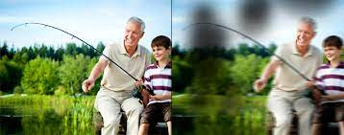

Age-related Macular Degeneration (AMD)
This is a degenerative condition which affects the central area of the eye. Effects are initially minimal however the symptoms will get worse as the diagnosis gets worse. People with advanced macular degeneration can maintain peripheral vision but don’t have central vision, making tasks like driving, recognising faces and reading difficult.

Example of Age-related Macular Degeneration vision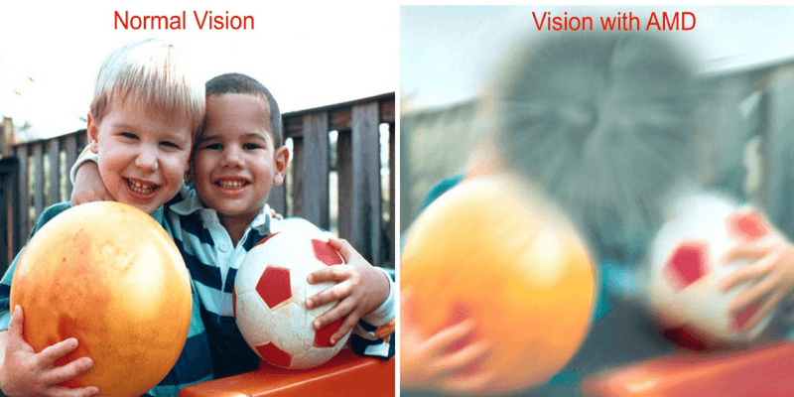

Glaucoma
Glaucoma is a disease which involves damage to the optic nerve resulting in substantial vision loss or complete blindness. The first symptom of Glaucoma is often a loss of peripheral vision. Tunnel vision can develop, resulting in only being able to see objects that are directly in front and extremely close.

Example of Glaucoma vision
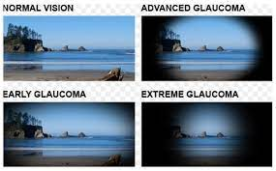

Cataracts
A cataract is the clouding of the naturally clear lens of the eye. When the lens becomes opaque, the amount of light that gets through the eye becomes more difficult to see. Blurry vision and glare sensitivity are common symptoms and colours may appear warped or distorted.
Example of Cataract vision
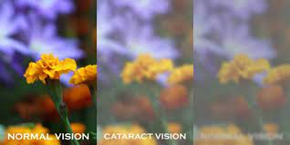

Refractive Error
Refractive errors are defects that result in light not being properly processed. These errors can cause a host of vision related issues including near sightedness, far sightedness and uneven focus.
Example of Refractive Error vision


Trachoma
This condition is chronic conjunctivitis through repeated or prolonged exposure to Chlamydia Trachomatis. This complication results in the eye lashes turning inwards, the resulting rubbing causing trauma and scarring to the eye which can lead to complete vision loss in later life.
Example of Trachoma vision


Retinitis Pigmentosa (RP)
This is a progressive degeneration of the retina caused by the retina not receiving the required protein to remain healthy. The condition predominately affects night vision and peripheral sight, however the vision is degenerative which can result in permanent blindness.
Example of Retinitis Pigmentosa


To learn more about the common vision conditions and the numbers of Australians affected, please refer to the Resources section of this toolkit for a list of online reputable sources.

Accessibility tools for people with low vision and blindness
At Guide Dogs, we offer a range of tools and technical solutions to assist with accessibility. These tools are used by people living with low vision or blindness to support them to live life on their terms.

Magnification
Magnification is the ability to increase the size of text and the size of images. This can be performed with a handheld device, like a magnifying glass or through screen magnification software.
Popular screen magnification programs for computers include:
- ZoomText
- Windows Magnifier
- SuperNova.
Along with computer magnifications you can also access magnifying tools on your mobile phones to increase the content on your screen.
More information about mobile phone accessibility is available in the Resources section of this toolkit.

Screen readers
Screen readers are exceptionally useful for people with blindness who can’t benefit from using magnification. A screen reader is a form of Assistive Technology (AT) that allows for text to speech reading of a computer screen.
Did you know?
Screen readers are available on most devices. Smart phones have built-in screen readers, as do games consoles, TVs and computers. There is also third-party screen reading software available for those devices that don’t have the technology built in.
Popular third-party screen readers include:
- JAWS (Job Access With Speech)
- NVDA (Non-Visual Desktop Access)
- Windows Narrator.

Canes
Canes are one of the most common forms of low vision accessibility for mobility. A long cane is a tactile mobility device that allows a user to safely navigate through their environment and to find a hazard before the user does.
A cane user is someone who uses a long white cane. You might have seen people using canes when you’ve been out and about in the shopping centre or on the street.
Did you know?
Canes no longer have to be white. Users all around the world can get customised canes so that they can express themselves. These days it’s common to see canes in all types of colours, including rainbow canes!

Accessibility fundamentals
There are a few simple tools and techniques that apply to most formats — email, social media and documents — that can make a huge difference to how your content is consumed. Consider the following fundamentals in your everyday activities and you’ll be well on your way to creating more accessible content for your audience.

Choose to use Word documents
Word documents are a screen reader’s best friend. Using a Word document that is well formatted is going to make it easy to read all the information. While PDF documents can be formatted to be accessible, this is more difficult and time-intensive to achieve. As a result, we recommend using Word documents where possible.
For more information on creating accessible Word documents, see the Formatting Documents section of this toolkit.

Colour and contrast
Colour can be a powerful tool for communicating messages with impact. However, it’s important to think about how and when you use colour, as this may not be accessible to everyone. Don’t rely on colour to convey meaning — instead use words and descriptions.
Contrast is about using different, easy-to-distinguish colours to identify things. You can find examples of contrast everywhere. Next time you see a road sign with a white background and black writing, you’ve experienced an example of something with high contrast.
You can easily simulate contrast on your computer screen. If you are using Windows:
- Hold left Alt, left Shift and press the Print Screen button.
- Press Enter to confirm and your screen will be switched to a high contrast setting.
- Repeat the gesture to undo it.

Describe visual information
Sound is a best friend to someone with low vision or blindness. Providing audio descriptions for different visual elements can help your content and information be consumed in new ways, that are accessible to all.
You may choose to add audio descriptions to videos to help explain what is appearing on the screen. Or you may provide a hand-held device that can explain different signs and information at your location. At Guide Dogs, we provide audio recordings of our important documents, such as our annual reports, to make sure that everyone who wants to learn more about our organisation can easily do so. You can find an example of the Guide Dogs Queensland audio Annual Report here: https://qld.guidedogs.com.au/wp-content/uploads/sites/5/2021/11/Guide-Dogs-Annual-Report_2021-2.mp3
To learn more about adding audio descriptions, visit the Social Media Accessibility and Resources sections of this toolkit.

Alternative text for images and photos
Photos and images are a wonderful way to get your message across and to engage your reader. To help people with low vision or blindness be able to understand that there is an image present and to know the context of the image, it’s important to include alt text (alternate text) and where possible, image descriptions.

Alt text and image descriptions
Alt text is a written description of an image that’s not visible to the standard reader but provides useful information for people using screen readers. If you have a picture that doesn’t have alt text, a screen reader will announce it simply as “image” which doesn’t provide any context of what the image is and can leave the reader confused.
An image description is a more detailed option for providing written information of images or video. This is more like an image caption, providing additional information and detail of the entire image. These are often used in emails, under photos in a document, or in website content.
Following is an image and example of the difference between alt text and an image description.

Alt Text: “A picture of a dog sitting on the path.”
Image Description: “A white Labrador puppy is sitting in the middle of a footpath, looking at the camera. The puppy wears a green harness that has the words ‘Guide Dog Puppy’ on it.”

To learn more adding alt text, see the Formatting Documents, Social Media Accessibility and Resources sections of this toolkit.

Formatting documents
Why is document accessibility important? If your information is accessible and can be read by all, then everyone has the ability to access, read and appreciate the content you’re releasing. There will be equal opportunity for everyone to get information about your services. Imagine the impact your organisation or community group could have if everyone is able to read and access your services!

Provide a Word document
Microsoft Word documents are easier to read with screen readers than PDFs and are the recommended format for providing accessible content.
To help reduce unwanted edits or changes to your Word documents, you can simply choose to save them as “read-only versions”, restrict any editing and “Mark as Final”.
To learn how to do this, visit: https://support.microsoft.com/en-us/office/help-prevent-changes-to-a-final-version-of-a-file-b1af610f-f172-42c9-85fc-a178a503cc81

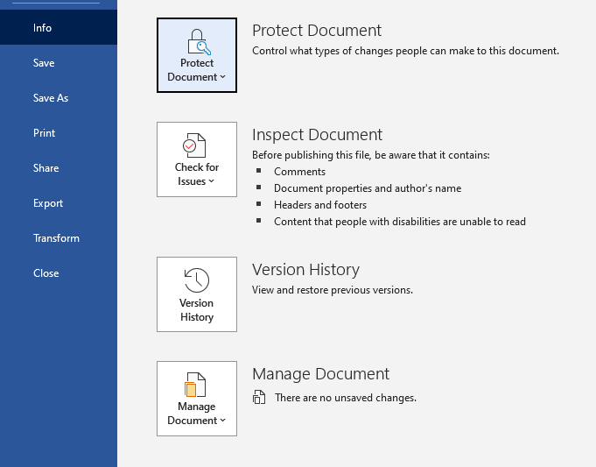

Note: This doesn’t stop someone from making a new copy of the document and saving it with changes. If you’re concerned about unwanted changes, we recommend providing both a Word and PDF version of a document. That way there is always a point of reference for what the original document should include.

Text formatting
Text is crucial for delivering information. What’s the golden rule of receiving information? You have to be able to read it! Here are a few tips when considering your text formatting:
- Use a font that is solid and easy to read — ideally a sans serif font.
For example: Arial is a sans serif font. Times New Roman is a serif font.
- Size is different for everyone but 12–14pt font size allows magnification users the ability to read information and screen reader users more information per line before having to scroll down.
- Consider contrast in your colour choice — black text on white background is more accessible.
- Don’t use colour to highlight meaning. For example, rather than highlight a section red, use additional words to describe the intent.
- Avoid italics, using UPPERCASE words and underlining.

Lists
Lists are a great way to present information quickly and succinctly. When using a list, be mindful of the layout and remember to be consistent. Try to use the same bullet point type throughout.
For a screen reader user, they will hear the names of the bullets as the list is read, so ensuring the same bullet point type avoids confusion.

Heading styles
Using headings in your documents makes it easy for a screen reader user to access information quickly.
Many people think that creating a heading is just bolding and underlining the text. While that will visually present a heading, it does not create a heading format that a screen reader can use. Rather, you need to create a heading style which allows for easy navigation.
We recommend using Heading 1 for the first heading on the page (see the process on how to do this below). This will come up for a screen reader user as “Heading Level 1”. This tells the user that this is the first heading, at the beginning of the content.
When using headings, make sure you keep going down in order.
For example, your first heading will be Heading 1. Your second heading will be Heading 2. More heading numbers will continue to be added every time you create a heading.

To create a heading
To apply a heading style, follow these steps provided by Microsoft:
- Select the text that you want to add a header to.
- Select Home > Styles (or press Alt+H, then L), and then select the heading you want, such as the Heading 1 button.
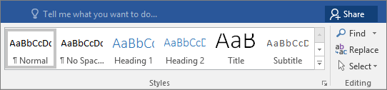
- Word applies a font and color change to help make it clear that this is a title — the Heading 1 of the article. The next heading type is a Heading 2.

To view these instructions online or learn more about heading styles and accessibility, visit Microsoft’s website: https://support.microsoft.com/en-gb/office/add-a-heading-3eb8b917-56dc-4a17-891a-a026b2c790f2

Pictures and images
To make pictures and images that are included in your document accessible, simply add alt text. Alt text is easy to create and gives screen reader users the ability to read and identify pictures.

Adding alt text to images in Microsoft Word, PowerPoint, Excel and Outlook
Follow the instructions provided by Microsoft to include alt text on your images:
- Insert your image or object.
- Right click the image or object.
- Select the option that says Edit Alt Text.
- A popup box will appear for you to write a description of the image.
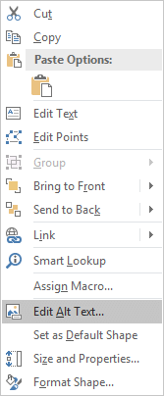
- In the Alt Text box, type one to two sentences in the text box to describe the object or image, and its context to someone who cannot see it.
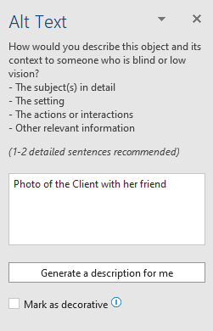
Alt text is sometimes automatically applied to images, however they are auto-generated and not as descriptive as they could be. So don’t be afraid to use your creative skills and words to describe the image!
To view these instructions online or learn more about heading styles and accessibility, visit Microsoft’s website: https://support.microsoft.com/en-gb/office/add-a-heading-3eb8b917-56dc-4a17-891a-a026b2c790f2

Checking your formatting with Accessibility Checker
Microsoft provides a built-in accessibility checker to help review your content in Word, Excel, PowerPoint and Outlook.
Follow the instructions provided by Microsoft below to check your accessibility:
- On the ribbon of the Microsoft Office app, select the Review tab. (Note: If you're using Outlook, you'll only see the Review tab when writing or replying to messages.)
- Select the upper part of the Check Accessibility split button. The Accessibility pane opens to the right of the screen and the Accessibility ribbon activates at the top of the screen.
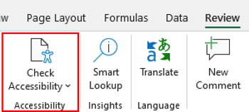
- In the Accessibility pane, review and address the findings.

To view these instructions online or learn more about using the Accessibility Checker, please visit Microsoft at: https://support.microsoft.com/en-us/office/improve-accessibility-with-the-accessibility-checker-a16f6de0-2f39-4a2b-8bd8-5ad801426c7f

Social media accessibility
Social media provides a great opportunity to build authentic connection and engagement with others in your community and audience. There are a few simple things you can do to ensure your social media content is able to be enjoyed and accessed by everyone.

Adding alt text
Most social media platforms now have the option to include alt text on an image.
Alt text provides a text-based alternative to non-text content such as images, videos, and gifs. While it doesn’t appear visually, it can easily be read by screen readers to provide the context of an image to people with low vision and blindness.
Alt text is usually made up of two or three words explaining the image. A screen reader will announce “graphic” and then read the alt text.
For example, on the social post example below, the alt text will be: “A group of Labrador puppies.”

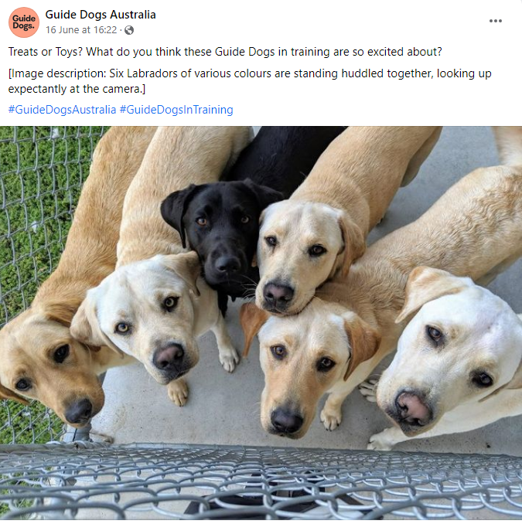

Alt text on Facebook
Follow these instructions from Facebook to see and edit alt text for a photo before you post it:
- Click Photo/Video at the top of your News Feed.
- Select the photo you want to add.
- Hover over the photo and click the pencil Edit icon.
- The automatically generated text will be shown on the left-hand side of your photo. Click Override generated alt text to edit it.
- Write your alt text in the box. To change back to the automatically generated text, click Clear.
- To save your alt text, click Save in the bottom left.
To change the alt text of a photo after you've posted it:
- Click the photo to open it.
- Click the three dots in the top right and select Change alt text.
- Click Override generated alt text or change the alt text in the text box. You can also click Clear to change your edited alt text back to the automatically generated text.
- Click Save.
To view these instructions online or learn more about adding alt text on Facebook, visit: https://www.facebook.com/help/214124458607871

Alt text on Instagram
Follow these instructions from Instagram to see and edit alt text for a photo before you post it:
- Start by taking a photo or uploading an existing photo to Instagram.
- Choose a filter and edit the image, then tap Next (iPhone) or the arrow icon (Android).
- Tap Advanced settings at the bottom of the screen.
- Tap Write alt text.
- Write your alt text in the box and tap Done (iPhone) or select the tick icon (Android).
To change the alt text of a photo after you've already posted it on Instagram:
- Go to the photo and tap the three dots in a line
- Tap Edit.
- Tap Edit alt text in the bottom right.
- Write the alt text in the box and tap Done (iPhone) or select the tick icon (Android).
To view these instructions online or learn more about adding alt text on Instagram, visit: https://help.instagram.com/503708446705527

Include image descriptions
Image descriptions provide more information and context about the images used in a social media post. Think of these like an image caption.
They are normally included in the content that is visible to the audience, and either included in the post itself, or in the first comment if there are content limits.
This description should include any words that are featured in an image or video followed by a description of the content itself.
These descriptions should also use square brackets to start and end the alt text to make it clear that they are image descriptions.
For example, on the social post below, there were two images, so two image descriptions were included:
- [Image description one: A photo of Guide Dog Graduate, Izzy sitting in a brown harness. Izzy is a yellow Labrador.]
- [Image description two: A photo of Guide Dog Graduate, Edwin sitting in a brown harness. Edwin is a black Labrador.]



Cut the capitals
While it can be tempting to use a lot of capital letters or slang in social media to seem more relaxed and approachable, this makes your content more difficult for screen readers. Rather, stick with plain language and good grammar so it’s easy to be understood by everyone.

Limit your emojis
Emojis can be a fun way to show emotion quickly, however they are often read out by a screen reader and can be misinterpreted or provide an awkward interruption to your message. For example, having a ☹ emoji will be read out as a ‘sad face’ which may not be as impactful as the visual element.

Watch how you use hashtags
Hashtags are a terrific way to help your content get more reach. Here are a couple of tips to help you use hashtags in a way that works for everyone:
- Capitalise the first letter in multi-word hashtags as these make them more legible and allow screen readers to pronounce them correctly. For example: the hashtag #socialmediaadvice is not as easy to read as #SocialMediaAdvice
- Put your hashtags and mentions at the end of your content. Punctuations marks get read out loud by screen readers and can interrupt the copy and therefore the message of your content.

Caption your video and story content
These days, more and more social media content is delivered through short videos and stories. To ensure your content is accessible, be sure to include:

Captions on all audio
Most social media platforms now offer the ability to auto-caption your video content. This is a great accessibility feature. Just make sure you check your captions for typos or errors before you publish!
To learn more about adding auto captions to social media posts, visit the Resources section of this toolkit.

Audio descriptions
Sometimes in videos there can be content that is only visual and doesn’t include a voice-over. In these instances, it’s important to include audio descriptions of what is appearing.
For example, often logos or website addresses appear at the end of a video. For someone with low vision or blindness, this content is not accessible. However, by simply adding a voice-over that describes the content (for example, “a Guide Dog logo appears”) they can access the same information as everyone else.
You can view some examples of videos with audio description from social media below:
https://www.facebook.com/GuideDogsAustralia/videos/364211332351803
https://www.facebook.com/GuideDogsAustralia/videos/676520003556874

If you’d like to see further examples of audio descriptions or understand more, check out the Resources section at the end of this toolkit.

Email accessibility
Making your emails easier to read means there’s more chance of someone responding to you in a timely manner. Whether you’re looking to improve your personal emails, or focusing more on making your marketing emails accessible, the below guidelines can help.

Use descriptive subject lines
Your subject lines should be brief but descriptive and give subscribers an accurate idea of what content is in your email. Effective subject lines aren't only good for accessibility, they also tend to increase overall subscriber engagement.

Add meaningful hyperlink text
People who use screen readers sometimes scan a list of links. Links should convey clear and accurate information about the destination. Instead of just saying “Click Here”, add some context about what they need to do and where the link will take them. For example, “Click here to view our holiday products”.

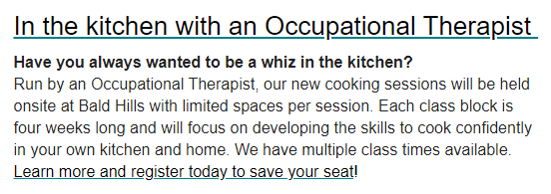

Consider your formatting
- Use a larger font size (12pt or larger).
- Choose a sans serif font (for example, Arial).
- Avoid using all capital letters and excessive italics and underlining.
- Include lots of white space between paragraphs.

Describe your images and graphics
Make sure you include alt text on images, and where relevant, consider also including image descriptions.
- Alt text should be short but descriptive and highlight the relevance of the image to your message.
- Image descriptions use more words to explain in detail what is included in an image (more like an image caption).
Don’t forget to also add descriptions to any form of visual content, including pictures, smart art graphics, shapes, embedded objects, videos and so on.
Below is an example of an image included in an email newsletter from Guide Dogs. The alt text is not visible, but the image description is included below.
You can also view the entire version of this email by visiting: https://us4.campaign-archive.com/?u=50cf15d6fe13b4a0459964af5&id=2f6d4a54df

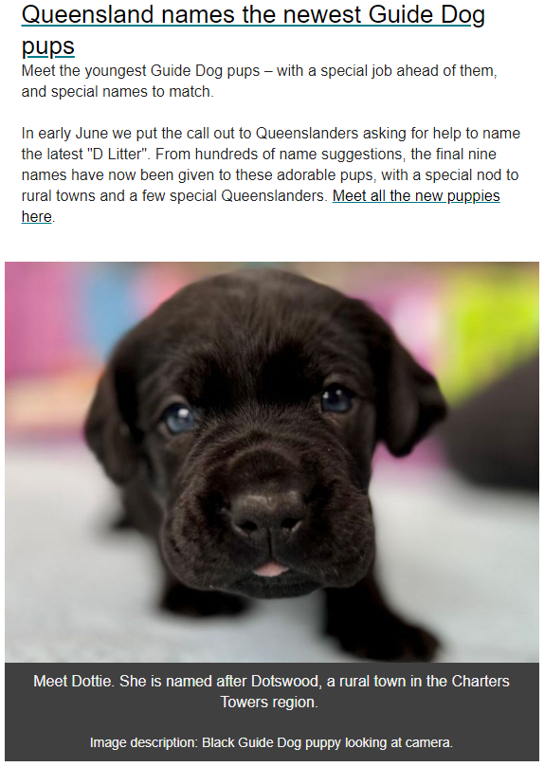

Check colour contrast
The text in your email should be readable in High Contrast mode so that everyone, including people with low vision and blindness, can see it as well. White and black colour schemes make it easy for people who are colourblind to distinguish text and shapes.
If you use a paid email campaign program, check to see if they offer any tools which allow you to assess your colour scheme.
MailChimp, for example, has a Colour Contrast Analyser tool available under the Inbox Preview tool: https://mailchimp.com/en-au/help/test-with-inbox-preview/
If you’re sending your email through Microsoft, Microsoft Office has an accessibility checking tool you can use to check emails and content. To learn more about this tool, visit the Formatting Documents and Resources sections of this toolkit.

Use an accessible template
If you have limited time or knowledge on creating accessible emails, it might be easier to speak with someone who is an expert in accessibility. Accessibility specialists can work with your organisation to develop email templates that are accessible and are suited to your communication needs.
For more information about email accessibility, please speak to one of the Accessibility Experts at Guide Dogs by phone on (07) 3500 9060 or email clients@guidedogsqld.com.au.

Website accessibility
Just like you would consider including a ramp for wheelchairs to allow access to your physical office or premises, it’s important to consider if your online presence is accessible. Having a website that is accessible to everyone helps your audience find out information about your organisation easily and quickly.
Here are a few guidelines you can follow to start improving your website today.

Describe your images
- Include alt text on all visual elements, including images, icons, logos and graphics.
- Where relevant, also consider including image descriptions or visible captions to help provide additional information about what the image is.

To learn more about alt text and image descriptions, visit the Accessibility Fundamentals section of this toolkit.

Consider colour contrast
While you will likely need to follow the brand guidelines and existing template of your website, it can be useful to consider your colour choices if designing a new website page. For example, avoid using pale colours on a pale background.
To learn more about colour contrast in websites, visit the following resources:
https://webaim.org/resources/contrastchecker/
https://color.a11y.com/

Design for different reading speeds
Not everybody reads or consumes content the same way. That’s why it’s important to consider the layout and format of your website content. A few things to make your content more accessible include:
- Using heading styles to break up the text.
- Using bullet points.
- Allowing white space in-between blocks of text.
- Using short, simple sentences.
- Use a free online ‘readability’ tool to check your content.

To check the readability of your website, try one of the below tools:
https://readable.com/
https://www.webfx.com/tools/read-able/
https://datayze.com/readability-analyzer.php

Use helpful hyperlink text
Make sure the hyperlinks in your written content provide clear and accurate information about where the user will go when they click the link.
You can do this by simply describing where the link will take the user and what the context is. For example, rather than saying “Learn more”, hyperlink a longer sentence such as "Learn more about our online fitness classes”.
Adding a hyperlink to a website will be slightly different for everyone, depending on the type of software your website is built on. To learn more about adding hyperlinks to your website, speak to someone within your team who manages the website or reach out to one of the Accessibility Experts at Guide Dogs for assistance.

Understand the standards for accessibility
There are further guidelines and information on website accessibility available in the World Wide Web Consortium’s website accessibility guidelines: https://www.w3.org/WAI/standards-guidelines/wcag/
This is a useful resource for any organisation looking to improve their website accessibility.

Work with an accessibility specialist
Every website is built differently. Work with an accessibility expert to understand what areas of improvement can be made to your website, and receive expert advice and training on how to achieve this.
To speak to an Accessibility Expert from Guide Dogs phone (07) 3500 9060 or email clients@guidedogsqld.com.au.

In closing
We hope you’ve found this toolkit useful in your journey to creating content and documents that are accessible to everyone.
At Guide Dogs, we work every day to empower people to find the solutions that will make the biggest differences to achieve independence, participation, inclusion and wellbeing. Thank you for being part of this work towards creating a world that is inclusive and provides equal opportunities for all.
If you have any additional questions or would like further support with Accessibility, please contact Guide Dogs on (07) 3500 9060 or email clients@guidedogsqld.com.au.

Additional resources

Low vision information and statistics
- Australian Institute of Health and Welfare — People with disability in Australia: https://www.aihw.gov.au/reports/disability/people-with-disability-in-australia/contents/people-with-disability/prevalence-of-disability

- Queensland Government – Disability Statistics: https://www.qld.gov.au/disability/community/disability-statistics

- Guide Dogs Queensland – Low vision conditions:
https://qld.guidedogs.com.au/get-resources/about-low-vision/

- Australian Institute of Health and Welfare — Indigenous eye health measures 2021: https://www.aihw.gov.au/reports/indigenous-australians/indigenous-eye-health-measures-2021/contents/summary

Mobile phone accessibility
- Apple: https://www.apple.com/accessibility/iphone/index.html

- Android: https://support.google.com/accessibility/android#topic=6007234

Formatting documents
- Microsoft — Accessibility: https://www.microsoft.com/en-us/accessibility

- Microsoft — Easy tips to create accessible content: https://query.prod.cms.rt.microsoft.com/cms/api/am/binary/RE4Y2lz

- Microsoft Accessibility Checker:
https://support.microsoft.com/en-us/office/improve-accessibility-with-the-accessibility-checker-a16f6de0-2f39-4a2b-8bd8-5ad801426c7f

Microsoft — Add a heading style:
https://support.microsoft.com/en-gb/office/add-a-heading-3eb8b917-56dc-4a17-891a-a026b2c790f2

- Media Access Australia — Audio descriptions:
https://mediaaccess.org.au/about/what-is-media-access/what-is-audio-description

Website accessibility and alt text
- Web Accessibility Initiative:
https://www.w3.org/WAI/fundamentals/accessibility-intro/

- Government of Western Australia – Disability Services Commission: https://www.disability.wa.gov.au/Global/Publications/Understanding%20disability/Built%20environment/Accessible%20websites%20checklist.pdf

- HubSpot: https://blog.hubspot.com/website/web-accessibility

- WordPress Engine: https://wpengine.com.au/resources/wordpress-image-alt-text/

- Webaim – Colour Contrast Checker: https://webaim.org/resources/contrastchecker/

- A11y – Color Contrast Accessibility Validator: https://color.a11y.com/

- Readable – Readability checker: https://readable.com/

- WebFX – Readability checker: https://www.webfx.com/tools/read-able/

- Datayze – Readability checker: https://datayze.com/readability-analyzer.php

Social media accessibility
- Facebook accessibility: https://www.facebook.com/help/273947702950567?helpref=search&query=accessibilty&search_session_id=4c0aff8077471b7eab3a6fedb2b31282&sr=6

- Captions on for Facebook videos:
https://www.facebook.com/help/427723640933279

- Instagram accessibility:
https://help.instagram.com/308605337351503/?helpref=hc_fnav

- Later – Captions on Instagram stories:
https://later.com/blog/add-captions-to-instagram-stories/

Email accessibility
- Mailchimp Accessibility:
https://mailchimp.com/en-au/help/accessibility-in-email-marketing/

- Mailchimp Inbox Preview tool: Inbox Preview tool: https://mailchimp.com/en-au/help/test-with-inbox-preview/

- Email on Acid:
https://www.emailonacid.com/blog/article/email-development/email-accessibilty-in-2017/

- Campaign Monitor:
https://www.campaignmonitor.com/resources/guides/accessibility/

- Microsoft Outlook:
https://support.microsoft.com/en-us/office/make-your-outlook-email-accessible-to-people-with-disabilities-71ce71f4-7b15-4b7a-a2e3-cf91721bbacb#:~:text=In%20Outlook%2C%20you%20can%20define,manually%20launch%20the%20Accessibility%20Checker.

