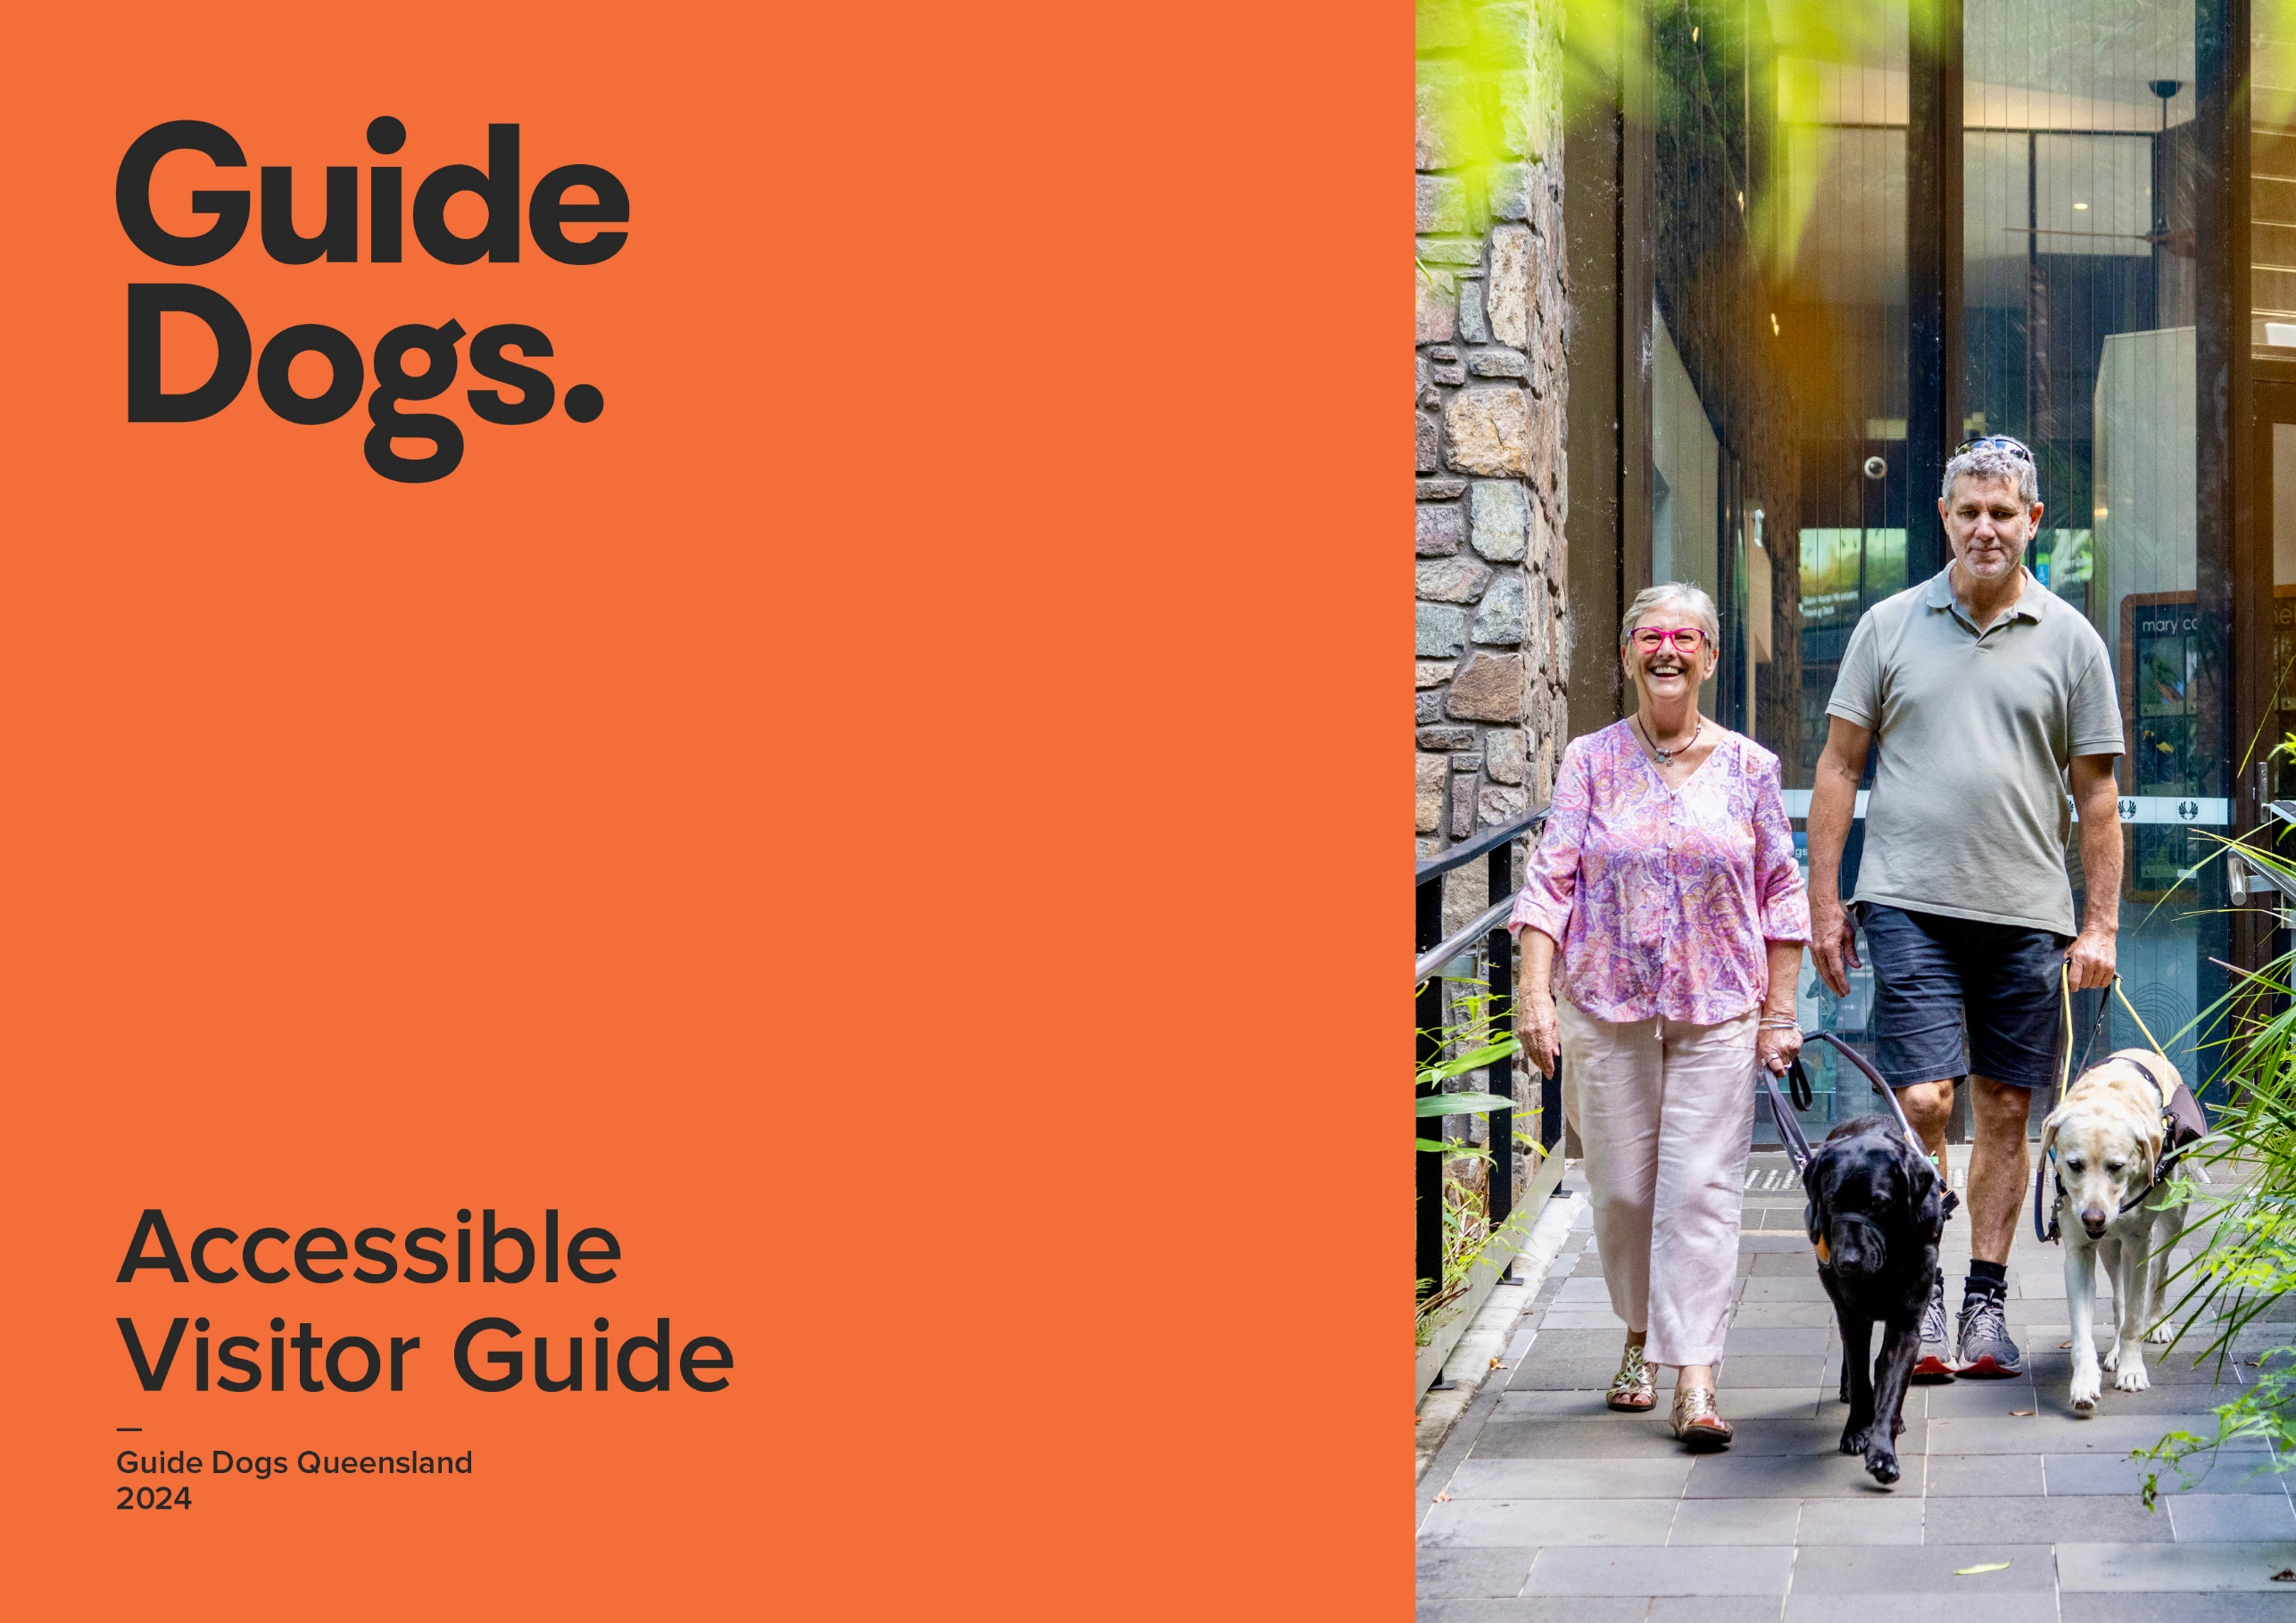

Accessible guide – [insert your location/experience name]
Accessible rooms | Availability | Details
Is there accessible accommodation?  Is the entry door a good width?  Are door handles easy to use?  Is there movement space at the door?  Are there visual alarm devices (VAD)? | Yes | Example: 2 rooms
Accessible bathroom
Does the bathroom have good door width?  Is there an accessible toilet?  Are there grab rails?  Is there clearance under the basin?  Is there a roll-in shower?  Is there a shower chair? | Yes | Example: Door width 867mm
Bedding
Is the bed at a good height for transferring?  Is there clearance around the bed?  Is there clearance under the bed? | Yes/No/Partial/ NA  Yes | Example: 65mm H
Furniture and fittings
Are switches/controls reachable seated?  Is the furniture easy to move?  Is clothes storage at a good height? | Yes/No/Partial/ NA | Example: Heavy chairs, staff happy to help

Kitchen
Are there cooking facilities?  Are appliances reachable while seated?  Are utensils reachable while seated? | Yes/No/Partial/ NA  Yes | Example: Located in second drawer
Balcony/courtyard
Is there level access to balcony/courtyard?  Is the doorway a good width? | Yes/No/Partial/ NA | Example:
Arrival, entry and facilities
Are there designated car parks?  Are they undercover with good clearance?  Is there a drop-off point?  Is the main entry path level and barrier-free? | Yes/No/Partial/ NA  No | Example:
Reception and entry
Is there a reception?  Is the entry door a good width?  Is there a Hearing Loop?  Is there a low-height counter?  Are there good seating options? | Yes/No/Partial/ NA  No | Example:
Common areas
Are walkways wide and level?  Is there clear signage?  Is the signage Braille/tactile?  Is there free Wi-Fi?  Is there a sensory or quiet space?  Is there a café or restaurant? | Yes/No/Partial/ NA  Yes | Example: Available in rooms and some common areas

Common areas (continued)
Are there good seating options?
Are there conference rooms?
Are there accessible toilets?
Lifts
Do the lifts cater for visitors with low vision or blindness?  Does the lift have good circulation space? | Yes/No/Partial/ NA  Yes | Example: 1094mm W x 2000mm D
Swimming pool
Is there a swimming pool?  Is the pool wheelchair accessible?  Are there steps and handrails? | Yes/No/Partial/ NA


